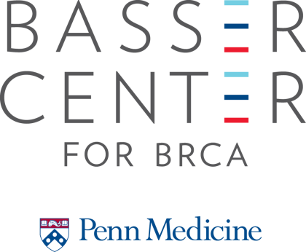

2021
Grants Program for Penn Investigators
Application Form
Deadline: April 2, 2021

Name (Last, First, Middle Initial):
Degrees:
Faculty Position:
Department:
Phone:
E-mail:

Project Title:

Award type:
□ Faculty Awards-$75,000-150,000 per year x 2 years
□ Early Career Awards-$75,000 for one year

Study Involves:
Human Subjects: □ Yes □ No Protocol #______________
Date Approved or Pending: _________

Vertebrate Animals: □ Yes □ No Protocol #______________
Date Approved or Pending: _________

Authorizing Signatures

PRINCIPAL INVESTIGATOR(S)/PROJECT DIRECTOR(S): I certify that the information contained in this application is accurate and complete as of this date. I agree to accept responsibility for scientific and technical conduct of this project and for provision of required progress reports if a grant is awarded as a result of this application. If an award is made as a result of this proposal, I will administer it in accordance with the policies of the Basser Center for BRCA.

Name(s):
Date:

Signature(s):

DEPARTMENT CHAIR: The attached application is approved. It is within the total program and academic objectives of the Department. Adequate space is available for the conduct of the project. The scope of research described herein is realistic. The information contained in the proposal is accurate and correct to the best of my knowledge.

Name:
Date:

Signature:

Basser Center for BRCA
Internal Research Grant Application

PROJECT ABSTRACT (do not exceed one paragraph; ~300 words):

Basser Center for BRCA
Internal Research Grant Application

SPECIFIC AIMS (do not exceed one page):

Basser Center for BRCA
Internal Research Grant Application

DESCRIPTION OF RESEARCH PROPOSED (no more than 5 pages):

- Significance

- Background

- Research Plan- Please include within this section:

- Clinical impact-how will funding the application accelerate advances in science that have the potential to change the standard of care for BRCA1/2 carriers in the future.
- Approach-describe the general research strategies that will address the overarching mission of the grant application, and show that the proposed research is BRCA1/2 specific. Specify how Basser Center core resources will be utilized, if appropriate. If gaps in existing facilities or resources are perceived to be a challenge for execution of the proposed research, applicants are encouraged to describe ways that funding could optimize facility services and operations.
- Metrics of success-Provide a list of no more than six specific metrics that are relevant to you grant application with a short term (e.g. 1-year) and long-term (5-year) time line. Scientific and clinical metrics should be emphasized and training metrics may also be included. Potential metrics may relate to novel discoveries based on observational or experimental research, development of new prevention or treatment modalities, advancing innovative clinical trials, and/or improvements in clinical operations.
- Sustainability-It is recognized that changes in these focus areas may require long-term investment beyond the initial 2-year funding period. Thus plans to promote the sustainability of the award beyond the funding period (e.g. SPORE grants, P01s, increased clinical revenues, philanthropy, etc.) should be mentioned.
- Data and Resource Sharing Plan- Please provide a short description of the data sharing plan for this project should final data be obtained, or, if data sharing is not possible, an explanation of why. All funded proposals should strive to create common resources for sharing with other Basser Center funded investigators. Examples include cell lines, plasmids, databases, etc.

Basser Center for BRCA
Internal Research Grant Application

REFERENCES (no page limit):

Basser Center for BRCA
Internal Research Grant Application

PROPOSED BUDGET:

Budget Justification:

